**Dental Clinic Services System**

Progress 3

Software Requirement Specification

By

**Kanokwan Maneerat 542115002**

**Worapun Wongkium 542115055**

Department of Software Engineering

College of Arts, Media, and Technology

Chiang Mai University

Project Adviser

______________________________

Miss Pattama Longani

**Software Requirement Specification**

**Revision Table**

|  |  |  |  |  |  |
| --- | --- | --- | --- | --- | --- |
| **Document Name** | **Detail** | **Status** | **Date** | **Viewable** | **Reviewer& Responsible** |
| DCSS – SRS - ver 0.1 | All new | Draft | 11/17/2014 | Adviser | Kanokwan & Worapun |
| DCSS – SRS - ver 0.2 | Double check the words | Draft | 11/20/2014 | Adviser | Kanokwan & Worapun |
| DCSS – SRS - ver 0.3 | Delete and add new URS and SRS | Draft | 11/28/2014 | Adviser | Kanokwan & Worapun |
| DCSS – SRS - ver 0.4 | Change some description | Draft | 12/01/2014 | Adviser | Kanokwan & Worapun |

**Table of Contents**

Chapter One: Introduction 5

Chapter One: Introduction 6

1. Introduction 6

1.1 Objectives 6

1.2 Project Scope 6

1.3 User Classes and Characteristics 7

Chapter Two: Overall Description 9

2. Overall Description 9

2.1 Product Perspective 9

2.2 Product Features 9

2.3 Design and Implementation Constraints 9

List of project constraints: 9

Chapter Three: User Requirement 10

3. User requirement 10

3.1 Dental clinic services system URS 10

Feature 4: Patient identification using QR code 10

3.2 Dental clinic services system SRS 11

4. System Features 14

4.1 User requirement specification with system requirement specification 14

4.2 Use Case Diagram 22

4.2.1 Dental clinic services system Use Case for Patient and Visitor 22

4.2.2 Dental clinic services system Use Case for Officer 23

4.2.3 Dental clinic services system Use Case for Dentist 24

4.3 Use case description 25

Use Case ID:UC-26View patients’ information and QR code(mobile) 25

Use Case ID:UC-27View patients’ information and QR code(in website) 27

Use Case ID:UC-28Add patient to a queue 29

Use Case ID:UC-29Reset queue 31

Use Case ID:UC-30Display his/her follow up message 33

Use Case ID:UC-31Post the question for following up with his/her patient 35

Use Case ID:UC-32Display follow up message 37

Use Case ID:UC-33Answer follow up question 39

Use Case ID:UC-34Display follow up message (mobile application) 41

Use Case ID:UC-35Answer follow up question (mobile application) 43

Use Case ID:UC-36Display dental clinic information and promotion(website) 45

Use Case ID:UC-37Display dental clinic information and promotion (mobile application) 47

Use Case ID:UC-38Add dental clinic information 49

Use Case ID:UC-39Edit dental clinic information 51

Use Case ID:UC-40Delete dental clinic information 53

Use Case ID:UC-41Display dental clinic information and promotion(website) 55

Use Case ID:UC-42Estimate the dental treatment cost (website) 57

Use Case ID:UC-43Estimate the dental treatment cost (mobile application) 59

Use Case ID:UC-44Estimate the dental treatment cost (website) 61

Use Case ID:UC-45Add dental treatment 63

Use Case ID:UC-46Edit dental treatment 65

Use Case ID:UC-47Delete dental treatment 67

Use Case ID:UC-48View dental treatment information 69

Use Case ID:UC-00Use the QR code to identify him/herself 71

# Chapter One: Introduction

## 1. Introduction

### 1.1 Objectives

Dental clinic service system consists of a web application and a mobile application which supports iOS7. The system supports English language for people who are patients, officers, or dentists of dental clinics. Furthermore, it offers some features for visitors who would like to gain information about the clinic. This system will reduce officers’ work and help patients save their time. Patients can find information about the dental clinic and personal information using the mobile application as well as the web application. For the visitor who wants to have a dental treatment from the clinic, and the dentist can use the system for checking their appointment schedule. Dental clinic services system integrates the services that are provided by most dental clinics into the web application and the mobile application. By combining all the services into one, the system provides more convenience to dental clinic users as well as staff.

This Software Requirement Specification has described in more detail of each requirement and each function that the system should have. The document includes the scope of the project, the system’s functionalities, user characteristic, functional requirements, and non-functional requirements.

## 1.2 Project Scope

The objective of this software requirement specification is to specify the requirements that the system should fulfill, which are as follows:

* Dental clinic services system provides an application that is accessible via web browser on a computer and also on a mobile phone.
* Dental clinic services system on mobile phone support iOS.
* Dental clinic services system supports English language only.
* Dental clinic services system provides features for dental clinics’ registered user whose are patients, officers and dentists.
* Dental clinic services system assists managing appointments of patients and dentists using the web application and the mobile application.
* Dental clinic services system provides a user authentication for each patient and dentist through dental clinic officers.
* Dental clinic services system provide features for generate QR code to patients from both web application and mobile application
* Dental clinic services system provide features for managing the queue of dental clinic
* Dental clinic services system assists following up treatment between dentist and patient
* Dental clinic services system provide the feature for promoting the clinic also managing those promotion and information
* Dental clinic services system help visitor and patient to predict the cost of dental care

### 1.3 User Classes and Characteristics

The system divides users into 4 groups. Information and characteristics of each group are listed below.

* **Visitor**

This group of user no needs to register to the system to use the services on the website or to use their mobile phone. Visitor is able to:

* Visitor can view dental clinic information and promotion
* Visitor can select dental treatment to estimate the cost
* **Patient**

This group of user needs to be registered to the system at the dental clinic. They will get patientID and password from the clinic to use the services on the website or to use their mobile phone. Patients use their patientID to login. Patients are able to:

* Patient can view their QR code.
* Patient can view follow up question.
* Patient can answer to follow up question.
* Patient can view dental clinic information and promotion.
* Patient can select dental treatment to estimate the cost.
* **Officer**

This group of users has the highest privilege in the system. They are given access to management functions for maintaining the system. Officers are able to:

* Officer can add patient to a queue and reset queue.
* Officer can add information and promotion into the website.
* Officer can edit information and promotion from the website.
* Officer can delete information and promotion from the website.
* Officer can add dental treatment and cost into the website.
* Officer can edit dental treatment and cost from the website.
* Officer can delete dental treatment and cost from the website.
* Officer can view all dental treatment.

**Dentist**

This group of user needs to be registered to the system at the dental clinic. They will register their account at the clinic. Dentist uses their dentistID and password to login to the system to use the services. Dentists are able to:

* Dentist can view their follow up question.
* Dentist can post question to follow up their patient

2. **1.4 Operation Environment**

Dental clinic services system uses web service technology and iOS technology. All the characters must have the Internet connection. Patients who want to use the mobile application must use a smartphone which supports iOS7.

**1.5** **Acronyms and Definitions Acronyms**

**Acronyms**

|  |  |
| --- | --- |
| **Acronyms** | **Stands for** |
| Registered User | Patient, Dentist, and Officer |
| Non-registered User | Visitor |
| PSR | Project Status Report |
| PM | Project Management |
| PMP | Project Management Plan |
| URS | User Requirement Specification |
| SRS | Software Requirement Specification |
| VSE | Very Small Entity |
| QR code | Quick Response Code |
| UC | Use Case |
| AD | Activity Diagram |
| UI | User Interface |
| UTC | Unit Test Case |
| STC | System Test Case |
| CD | Class Diagram |
| SD | Sequence Diagram |

# Chapter Two: Overall Description

## 2. Overall Description

### 2.1 Product Perspective

The Dental clinic services system consists of a mobile application base on iOS and a web application. The system helps patients save their time to contact the dental clinic by providing features such as making an appointment, viewing upcoming appointment, and getting cost estimation. It helps dentist to follow up their patients and check their appointments and schedule. Also the system reduces works of officers by providing them with features such as using QR code to identify patients at the clinic, managing appointments for patients and dentists. This system combines most of dental clinics' services into one application.

### 2.2 Product Features

The dental clinic services system offers seven features.

* Feature 1: Schedule management
* Feature 2: User registration and authentication
* Feature 3: Appointment management
* Feature 4: Patient identification using QR code
* Feature 5: Dental care consulting and following up
* Feature 6: A dental clinic information and promotion
* Feature 7: Cost estimation of dental treatments

Each of features will create a step-by-step suit by priority. In this progress we will develop Feature 4, 5, 6, and 7

### 2.3 Design and Implementation Constraints

### List of project constraints:

* The application works only on iOS version7.
* The application requires the Internet connection.
* The application is available for users who are already registered to the system to use all the services and who are not registered to the system will be a visitor whose can be able to use only some services.

# Chapter Three: User Requirement

## 3. User requirement

## 3.1 Dental clinic services system URS

## Feature 4: Patient identification using QR code

* URS-26: Patient can view their QR code from mobile application
* URS-27: Patient can view their QR code from website
* URS-28: Officer can add patient to a queue
* URS-29: Officer can reset queue
* URS-00: Patient use the QR code to identify him/herself

### 3.2 Dental clinic services system SRS

**SRS-61:** System shall generate the patient’s QR code in mobile application

**SRS-62:** System shall provide the patient’s QR code in the website

**SRS-63:** System shall provide the dent follow up page in the website

**SRS-64:** System shall provide the follow up form in the dent follow up page in the website

**SRS-65:** System shall provide the follow up page in the mobile application

**SRS-66:** System shall provide the answer follow up form in the follow up page in the mobile application

**SRS-67:** System shall retrieve the follow up’s data including patientID, dentistID, question, answer, question time, and answer time from followup table the dentalclinic database

**SRS-68:** System shall provide the follow up’s data including question, answer, question time, and answer time as a list from followup table the dentalclinic database into the dent follow up page in website

**SRS-69:** System shall add the patient’s message data including answer into the followup database in the dentalclinic database

**SRS-70:** System shall add the dentist’s message data including question and answer into the dentalclinic database

**SRS-71:** System shall update follow up table in the dentalclinic database

**SRS-72:** System shall provide the follow up’s data including question, answer, question time, and answer time as a list from followup table the dentalclinic database into the follow up page in mobile application

**SRS-73:** System shall retrieve the dental information’s data or promotion’s data including infoID, title, and details from the information table in the

**SRS-74:** System shall provide the dental information’s data or promotion’s data including infoID, title, and details from the information table in the dentalclinic database into the edit information and promotion form

**SRS-75:** System shall provide the dental clinic information and promotion’s data including title and details from information table in the dentallcinic database into the information and promotion page in in the website

**SRS-76:** System shall provide the create dental treatment page

**SRS-77:** System shall provide the dental clinic information and promotin’s data including title and details from information table in the dentallcinic database into the information and promotion page in the website

**SRS-78:** System shall provide the dental clinic information and promotion’s data including title and details from information table in the dentallcinic database into the information and promotion page in the mobile application

**SRS-79:** System shall provide the create information and promotion page

**SRS-80:** System shall add dental clinic information’s data or promotion’s data including type,title and details into the information table in dentalclinic database

**SRS-81:** System shall update information table in the dentalclinic database

**SRS-82:** System shall edit dental clinic information’s data or promotion’s data which are type, title, and details in information and promotion table in the dentalclinic database

**SRS-83:** System shall delete dental clinic information’s data or promotion’s data from information in the dentallcinic database

**SRS-84:** System shall provide the dental information and promotion as a list including title and details from information table in the dentalclinic database into all information and promotion page

**SRS-85:** System shall provide the cost estimation page in website

**SRS-86:** System shall provide the cost estimation page in mobile application

**SRS-87:** System shall retrieve the dental treatments’ data including treatmentID, dental treatment name, treatment cost from the treatment table in dentalclinic database

**SRS-88:** System shall provide the dental treatment’s data as a list including treatmentID, dental treatment name, treatment cost from the treatment table in dentalclinic database into the cost estimation page in website

**SRS-89:** System shall calculate the cost of dental treatment by using the treatment cost that user selected

**SRS-90:** System shall provide the totally cost of dental treatment that the user selected in the cost estimation page

**SRS-91:** System shall provide the dental treatment’s data as a list including treatmentID, dental treatment name, treatment cost from the treatment table in dentalclinic database into the cost estimation page in mobile application

**SRS-92:** System shall add the dental treatment information data including dental treatment name, treatment cost into the treatment table in the dentalclinic database

**SRS-93:** System shall update the dental treatment table in the dentalclinic database

**SRS-94:** System shall edit dental treatment’s data, which are treatmentID, treatment name, treatment cost in dental treatment table in the dentalclinic database

**SRS-95:** System shall delete dental clinic treatment’s data from dental treatment table in the dentalclinic database

**SRS-96:** System shall provide the dental treatment’s data including treatmentID, dental treatment name, treatment cost from the treatment table in dentalclinic database into the dental treatment edit form

**SRS-97:** System shall provide the patient follow up page in the website

**SRS-98:** System shall provide the follow up form in the patient follow up page in the website

**SRS-99:** System shall provide the follow up’s data including question, answer, question time, and answer time as a list from followup table the dentalclinic database into the follow up page in website

**SRS-100:** System shall return true if the question is already save

**SRS-101:** System shall return false if the question is not saved yet

**SRS-102:** System shall return true if the answer is already save

**SRS-103:** System shall return false if the answer is not saved yet

**SRS-104:** System shall provide the dental treatment data as a list in that is including with treatmentID, treatment name and treatment cost in all dental treatment pages

**SRS-105:** System shall provide the patients’ information including QR code in view information page in mobile application

**SRS-106:** System shall provide the patients’ information including QR code in view information page in the website

**SRS-107:** System shall provide page for checking an appointment date and time

**SRS-108:** System shall check time of input patientID and return the time of appointment

**SRS-109:** System shall check time of input patientID and return “Not today” for not match date

**SRS-110:** System shall check time of input patientID and return “No appointment” for the patientID that are not appointed

**SRS-111:** System shall check time of input patientID and return “You’re missed” for the patientID that are late

**SRS-112**: System shall provide check time result page

**SRS-113:** System shall provide the add queue page to add patient to a queue

**SRS-114:** System shall add patient into a queue

**SRS-115:** System shall shift patient to a next queue

**SRS-116:** System shall provide the add queue page to add patient to a queue

**SRS-117:** System shall provide the page for reset a queue

**SRS-118:** System shall set all queue to be empty

**SRS-119:** System shall retrieve the patient’s appointment data from appointment table that including patientID, dentistID, appointment date, start time, end time, treatment and description from dentalclinic database

**SRS-120:** System shall provide the patient’s appointment data from appointment table that including patientID, dentistID, appointment date, start time, end time, treatment and description from dentalclinic database in the patient appointment page

**SRS-121:** System shall provide the follow up’s data including question, answer, question time, and answer time into the answer follow up form in follow up page in the website

**SRS-122:** System shall provide the follow up’s data including question, answer, question time, and answer time into the answer follow up form in follow up page in the mobile application

**Chapter Four: System Features**

## 4. System Features

### 4.1 User requirement specification with system requirement specification

**URS-26:** Patient can view their QR code from mobile application

**SRS-01:** System shall connect with the dentalclinic database

**SRS-38:** System shall retrieve patients’ data including patientID, password, first name, last name, age, gender, address, tel., email, and treatment from patient table in the dentalclinic database

**SRS-61:** System shall generate the patient’s QR code in mobile application

**SRS-109:** System shall provide the patients’ information including QR code in view information page in mobile application

**URS-00:** Patient can use the QR code to identify him/herself

**SRS-01:** System shall connect with the dentalclinic database

**SRS-122:** System shall retrieve the patient’s appointment data from appointment table that including patientID, dentistID, appointment date, start time, end time, treatment and description from dentalclinic database

**SRS-123:** System shall provide the patient’s appointment data from appointment table that including patientID, dentistID, appointment date, start time, end time, treatment and description from dentalclinic database in the patient appointment page

**URS-27: Patient can view their QR code from website**

**SRS-01:** System shall connect with the dentalclinic database

**SRS-38:** System shall retrieve patients’ data including patientID, password, first name, last name, age, gender, address, tel., email, and treatment from patient table in the dentalclinic database

**SRS-62:** System shall provide the patient’s QR code in the website

**SRS-110:** System shall provide the patients’ information including QR code in view information page in the website

**URS-28: Officer can add patient to a queue**

**SRS-01:** System shall connect with the dentalclinic database

**SRS-111:** System shall provide page for checking an appointment date and time

**SRS-112:** System shall check time of input patientID and return the time of appointment

**SRS-113:** System shall check time of input patientID and return “Not today” for not match date

**SRS-114:** System shall check time of input patientID and return “No appointment” for the patientID that are not appointed

**SRS-115:** System shall check time of input patientID and return “You’re missed” for the patientID that are late

**SRS-116**: System shall provide check time result page

**SRS-117:** System shall provide the add queue page to add patient to a queue

**SRS-118:** System shall add patient into a queue

**SRS-119:** System shall shift patient to a next queue

**URS-29: Officer can reset queue**

**SRS-01:** System shall connect with the dentalclinic database

**SRS-117:** System shall provide the add queue page to add patient to a queue

**SRS-120:** System shall provide the page for reset a queue

**SRS-121:** System shall set all queue to be empty

### 4.2 Use Case Diagram

#### 4.2.1 Dental clinic services system Use Case for Patient and Visitor

**Patient and Visitor**

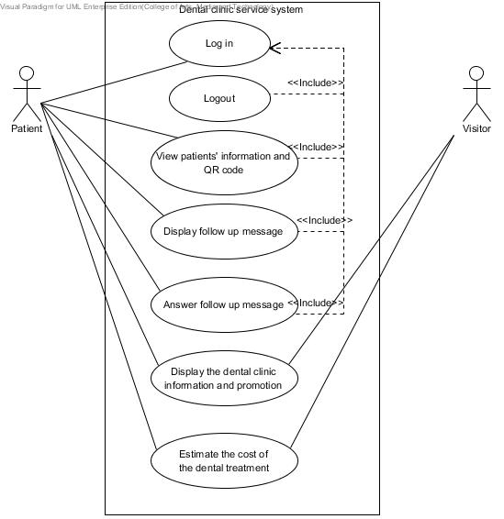

Figure 1: Dental clinic services system patient use case diagram

#### 

#### 4.2.2 Dental clinic services system Use Case for Officer

**Officer**

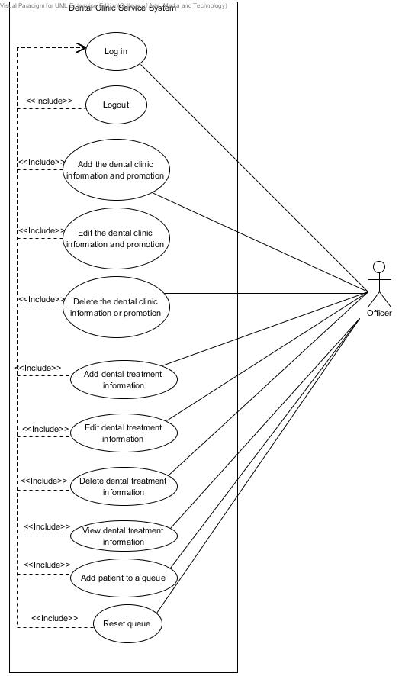

Figure 2: Dental clinic services system officer use case diagram

#### 4.2.3 Dental clinic services system Use Case for Dentist

**Dentist**

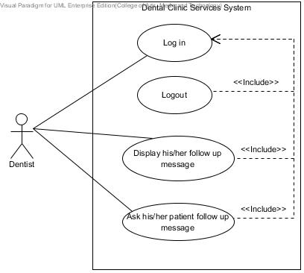

Figure 4: Dental clinic services system dentist use case diagram

### 4.3 Use case description

|  |  |  |  |
| --- | --- | --- | --- |
| Use Case ID: | UC-26 | | |
| Use Case Name: | View patients’ information and QR code(mobile) | | |
| **Created By:** | Worapun Wongkium | **Last Updated By:** | Kanokwan Maneeerat |
| **Date Created:** | 15/09/2014 | **Last Revision Date:** | 19/10/2014 |
| **Actors:** | Patient | | |
| **Description:** | Patient can view their own details and QR code. QR code you identify the patient at the clinic. | | |
| **Trigger:** | Patient select the patients’ details menu | | |
| **Preconditions:** | Patient is already logged into the application by using patientID and password | | |
| **Postconditions:** | Patient can view QR code and use QR code to identify his/her self at the clinic | | |
| **Normal Flow:** | 1. Patient selects “Details” menu in the mobile application 2. System shall connect with the dentalclinic database 3. System shall retrieve patients’ data including patientID, password, first name, last name, age, gender, address, tel., email, and treatment from patient table in the dentalclinic database 4. System shall generate the patient’s QR code in mobile application 5. System shall provide the patients’ information including QR code in view information page in mobile application 6. Patient can view QR code and use QR code to identify his/her self at the clinic | | |
| **Alternative Flows:** | N/A | | |
| **Exceptions:** | The patient will not have the QR code if he/she does not register to the dental clinic. | | |

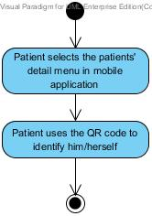

Figure 5: Display patients’ information and QR code in website [AD-22]

|  |  |  |  |
| --- | --- | --- | --- |
| Use Case ID: | UC-27 | | |
| Use Case Name: | View patients’ information and QR code(in website) | | |
| **Created By:** | Kanokwan Maneeerat | **Last Updated By:** | Kanokwan Maneeerat |
| **Date Created:** | 19/10/2014 | **Last Revision Date:** | 19/10/2014 |
| **Actors:** | Patient | | |
| **Description:** | Patient can view their own details and QR code. QR code you identify the patient at the clinic. | | |
| **Trigger:** | Patient select the patients’ details menu | | |
| **Preconditions:** | Patient is already logged into the website by using patientID and password | | |
| **Postconditions:** | Patient can view QR code | | |
| **Normal Flow:** | 1. Patient selects “Your Details” menu in the mobile application 2. System shall connect with the dentalclinic database 3. System shall retrieve patients’ data including patientID, password, first name, last name, age, gender, address, tel., email, and treatment from patient table in the dentalclinic database 4. System shall generate the patient’s QR code in the website 5. System shall provide the patients’ information including QR code in view information page in in the website | | |
| **Alternative Flows:** | N/A | | |
| **Exceptions:** | The patient will not has the QR code if he/she does not register to the dental clinic. | | |

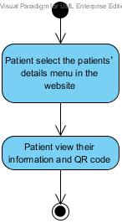

Figure 6: Display patients’ information and QR code in mobile application [AD-23]

|  |  |  |  |
| --- | --- | --- | --- |
| Use Case ID: | UC-28 | | |
| Use Case Name: | Add patient to a queue | | |
| **Created By:** | Kanokwan Maneeerat | **Last Updated By:** | Kanokwan Maneeerat |
| **Date Created:** | 19/10/2014 | **Last Revision Date:** | 19/10/2014 |
| **Actors:** | Officer | | |
| **Description:** | Officer can input patientID from QR code reader to add a patient into a queue | | |
| **Trigger:** | Officer select the add queue menu | | |
| **Preconditions:** | Officer is already logged into the website by using officerID and password | | |
| **Postconditions:** | Patient added to a queue | | |
| **Normal Flow:** | 1. Officer selects the add queue menu 2. System shall connect with the dentalclinic database 3. System shall provide page for checking an appointment date and time 4. System shall check time of input patientID and return the time of appointment 5. System shall provide the add queue page to add patient to a queue 6. System shall add patient into a queue | | |
| **Alternative Flows:** | 4a. System shall check time of input patientID and return “Not today” for not match date   1. System shall provide check time result page   4b. System shall check time of input patientID and return “No appointment” for the patientID that is not appointed   1. System shall provide check time result page   4c. System shall check time of input patientID and return “You’re missed” for the patientID that is late   1. System shall provide check time result page | | |
| **Exceptions:** | System will not connect to the database and deliver information if there is no internet connection. | | |

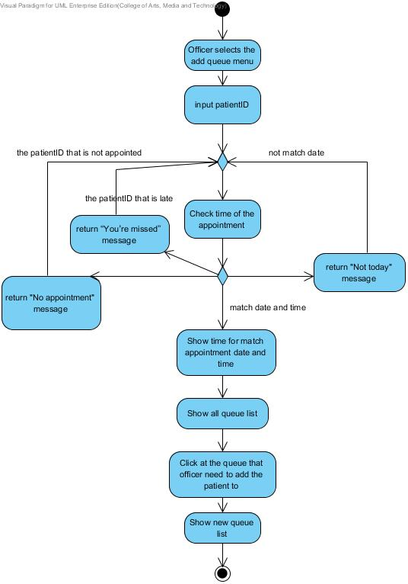

Figure 7: Add patient to a queue [AD-24]

|  |  |  |  |
| --- | --- | --- | --- |
| Use Case ID: | UC-29 | | |
| Use Case Name: | Reset queue | | |
| **Created By:** | Kanokwan Maneeerat | **Last Updated By:** | Kanokwan Maneeerat |
| **Date Created:** | 19/10/2014 | **Last Revision Date:** | 19/10/2014 |
| **Actors:** | Officer | | |
| **Description:** | Officer can reset a queue every end of the day to clear the queue for the next day | | |
| **Trigger:** | Officer select the reset queue button in the add queue page | | |
| **Preconditions:** | Officer is already logged into the website by using officerID and password | | |
| **Postconditions:** | A queue is empty | | |
| **Normal Flow:** | 1. Officer select the reset queue button in the add queue page 2. System shall provide the page for reset a queue 3. System shall connect with the dentalclinic database 4. Officer select the confirm button 5. System shall set all queue to be empty | | |
| **Alternative Flows:** | 4a. Officer not select confirm button   1. System shall provide the add queue page to add patient to a queue | | |
| **Exceptions:** | System will not connect to the database and deliver information if there is no internet connection. | | |

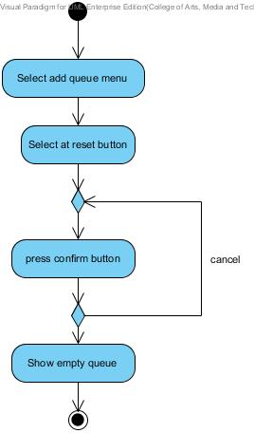

Figure 8: Reset queue [AD-25]

|  |  |  |  |
| --- | --- | --- | --- |
| Use Case ID: | UC-00 | | |
| **Use Case Name:** | Use the QR code to identify him/herself | | |
| **Created By:** | Kanokwan Maneerat | **Last Updated By:** | Worapun Wongkium |
| **Date Created:** | 19/10/2014 | **Last Revision Date:** | 19/10/2014 |
| **Actors:** | Patient | | |
| **Description:** | Patient can use the QR code to identify him/herself | | |
| **Trigger:** | Patient selects QR code function | | |
| **Preconditions:** | Patient is already logged in to the website by using patientID and password | | |
| **Postconditions:** | Patient can view the his/her personal information | | |
| **Normal Flow:** | 1. Patient select at all treatment menu 2. System shall connect with the dentalclinic database 3. System shall retrieve the patient’s appointment data from appointment table that including patientID, dentistID, appointment date, start time, endtime, treatment and description from dentalclinic database 4. System shall provide the patient’s appointment data from appointment table that including patientID, dentistID, appointment date, start time, endtime, treatment and description from dentalclinic database in the patient appointment page 5. Patient can view the his/her personal information including the appointment date | | |
| **Alternative Flows:** | N/A | | |
| **Exceptions:** | System will not connect to the database and deliver information if there is no internet connection. | | |